**Zatis Clothing**



Welcome to the world of ZATIS Clothing, where we embrace the magic of the possibilities within everyday life. An amalgamation of western fashion forward styles, high quality and great value is what makes ZATIS truly unique. Each style is created with this special feeling, which resonates with the self -confidence, style and carefree attitude of the style conscious millennial.

Incorporating the latest trends ZATIS curates a unique version of fashion, keeping in mind the exclusive and differentiated fashion moments each girl come across.

Itcaters to thoughtful shoppers who appreciate unique designs and top-quality pieces you just can’t find anywhere else. We are constantly curating fresh new collections and looking for the next big thing our customers will love. We are proud to be your Online Clothing Shop that you can rely on for our expert service and care.

**Mission:**

Our Missionis to make a difference through our branding by staying ahead of the fashion trends, defining style and giving customers what they want.

**Vision:**

Our Vision is to change the way our society connects with the fashion industry by providing our customers with products that are ethically and responsibly sourced.

**Promotional Focus:**

* Optimizing the SEO
* Building shopper friendly Website
* Promoting via social media platforms
* Boost the social media presence
* Consider using Influencer
* Social media advertising

**Analytics Report**

**Wix Analytics**

**Website Link:** https://zatisclothing.wixsite.com/zatis-clothing```

**Traffic Overview:**

Traffic Overview shows our site's traffic metrics, including:

* **Site Sessions:** A session is a web visit of a site visitor. A session starts when a visitor reaches your site, and ends after 30 minutes of inactivity. In each session there can be multiple page views and actions performed by a visitor, and each visitor can visit more than once.
* **Unique Visitors:**A Visitor is a person who visited your site, unique by device and browser. Therefore, if the same person visits from 2 different devices, they will be counted as 2 different visitors.
* **Average Session Duration:** How much time on average each session lasted on your website.
* **Top Traffic Sources by Sessions:** Which sites are driving traffic to your site.
* **Top Pages by Sessions:**Shows which pages on your site are visited the most.

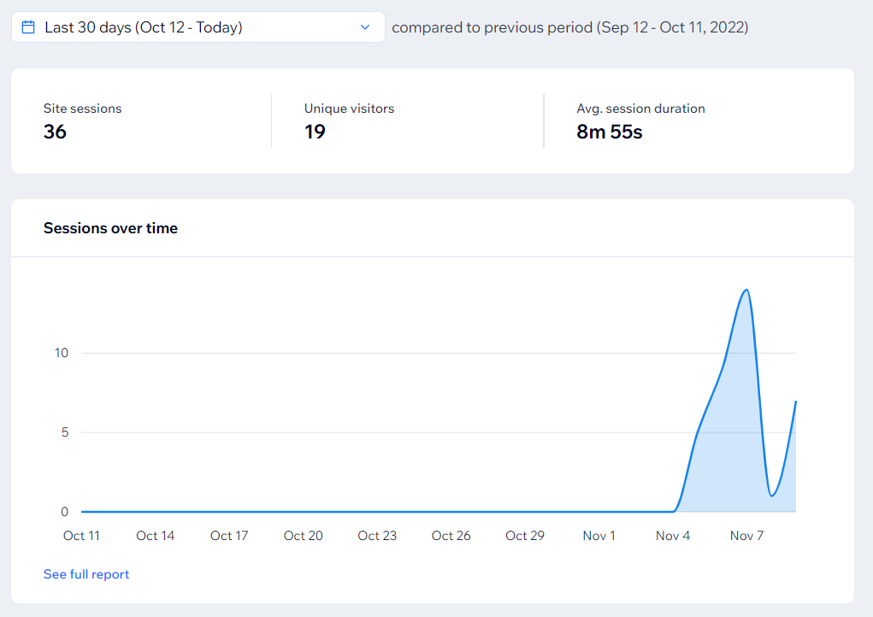

* **Sessions by Device:**The amount of visitors to your site using a desktop, mobile, or tablet.
* **New Vs Returning Visitors:**Amount of new visitors, returning visitors, and the total Unique Visitors to your site.
* **Sessions by Country:** Which countries your visitors are located in when they visit your site.

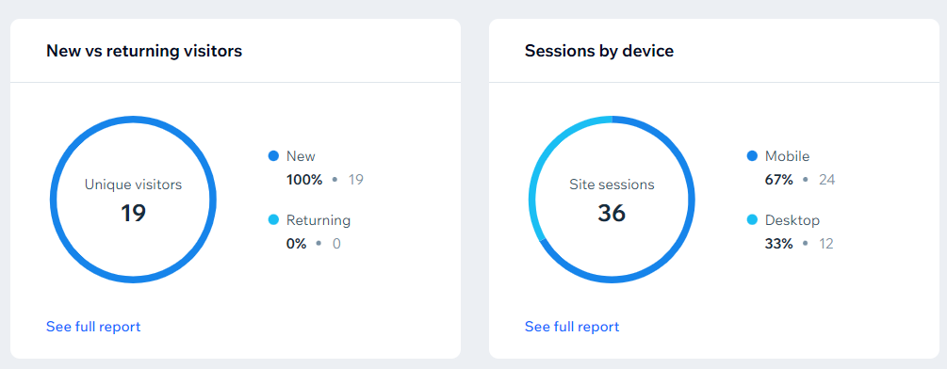

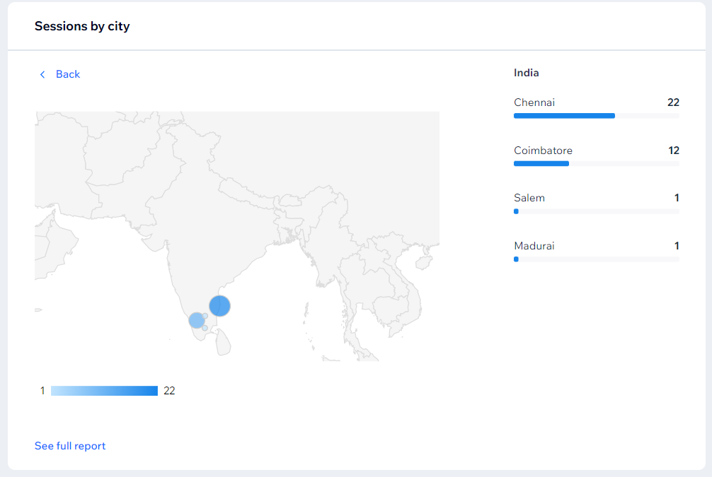

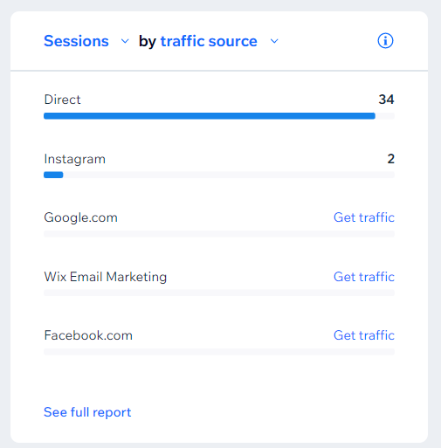

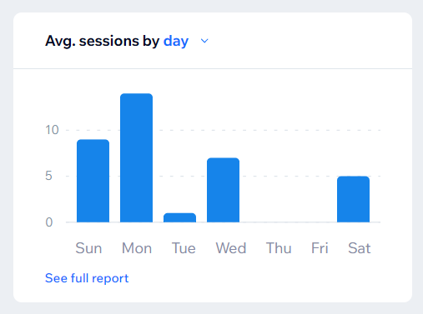

**Behavior Overview**

Behavior Overview demonstrates your visitor engagement data, and links to full reports for deeper analysis. The information on your overview includes:

* **Average Pages Per Session:** How many pages on average were visited during each session.
* **Bounce Rate:** The percentage of visitors that leave your site after viewing just one page.
* **Average Session Duration:** How much time on average each session lasted on your website.

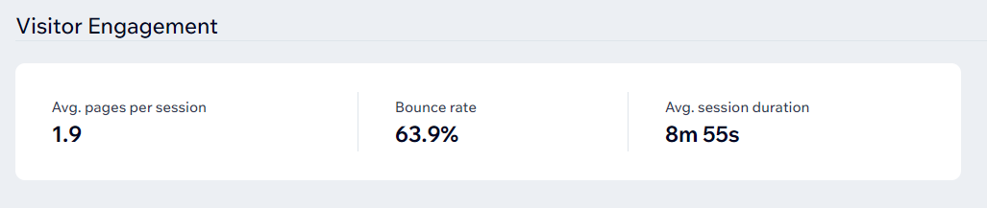

* **Top Navigation Flows:** How your site visitors navigate around your site pages.

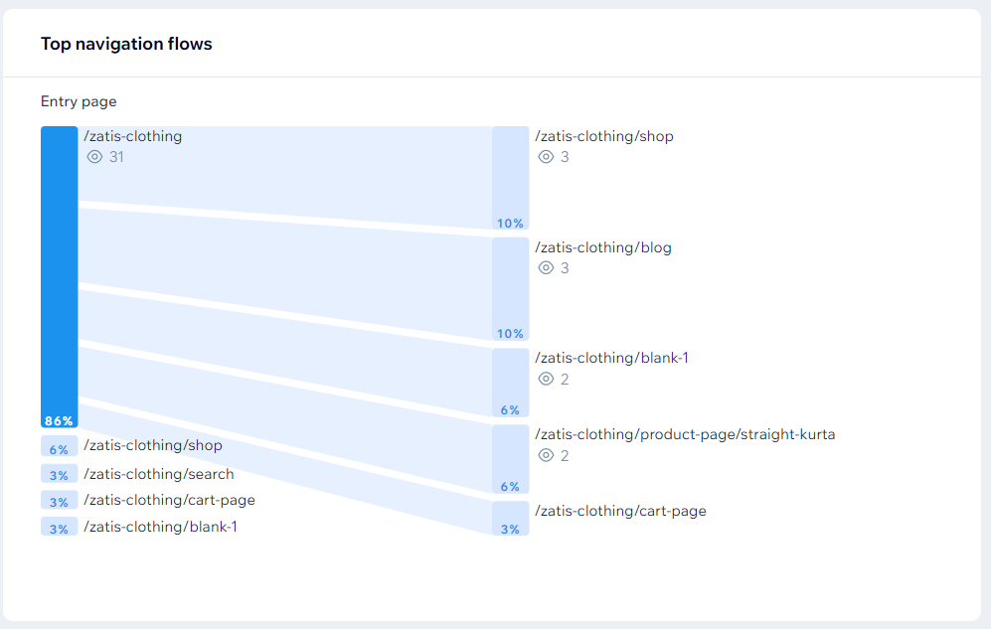

* **Most popular pages:**The pages on your site which receive the most traffic.
* **Most Time Spent:** The pages on your site which visitors spend the most time on.
* **Most exited page:** The last page your visitors see before leaving your site.

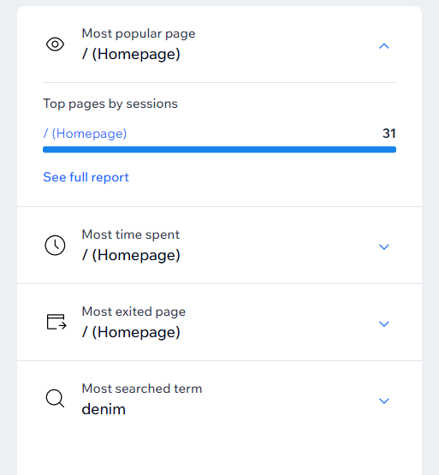

For sites collecting lead data, you can see information about your leads, including:

* **Clicks to contact:**Site sessions where a visitor clicked to contact you via WhatsApp, phone or email.
* **New leads:** Visitors who shared their contact details, or started a purchase but didn't complete it right away.

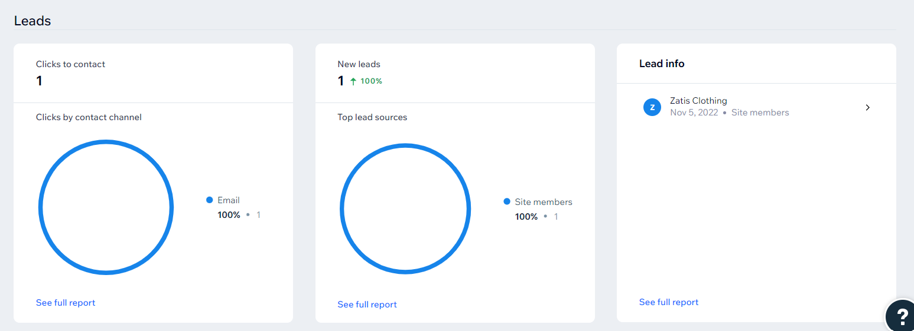

**YouTube Analytics**

**YouTube URL:** https://www.youtube.com/channel/UCT0yRzrgJ-pUa4lBlwuzXzw

In this scenario, you should be tracking:

**Video Views:** The number of times people have watched your videos—the bigger the number of views, the higher your YouTube SEO rating would be and the better you perform in YouTube search.

**Average view duration:**this is determined by total view time/total video playback (including replays.) A higher average viewing time means that your viewer finds your specific video useful.

**Estimated watch time:** how much time the audience spends viewing individual videos.

**The growth rate of subscribers:** the number of subscribers that you’ve gained and lost over time.

Say you want to connect with your audience. So, you should focus on your engagement metrics and track where your subscribers are coming from. Here’s what you should measure:

* **Likes and dislikes:** the number of likes and dislikes on your videos.
* **Shares:**the number of times your videos have been shared by your target audience.
* **Video watching by device type:** which devices people are using to watch your videos.
* **Views by country:** from which countries (or states) your traffic originates. In other words, traffic source types.

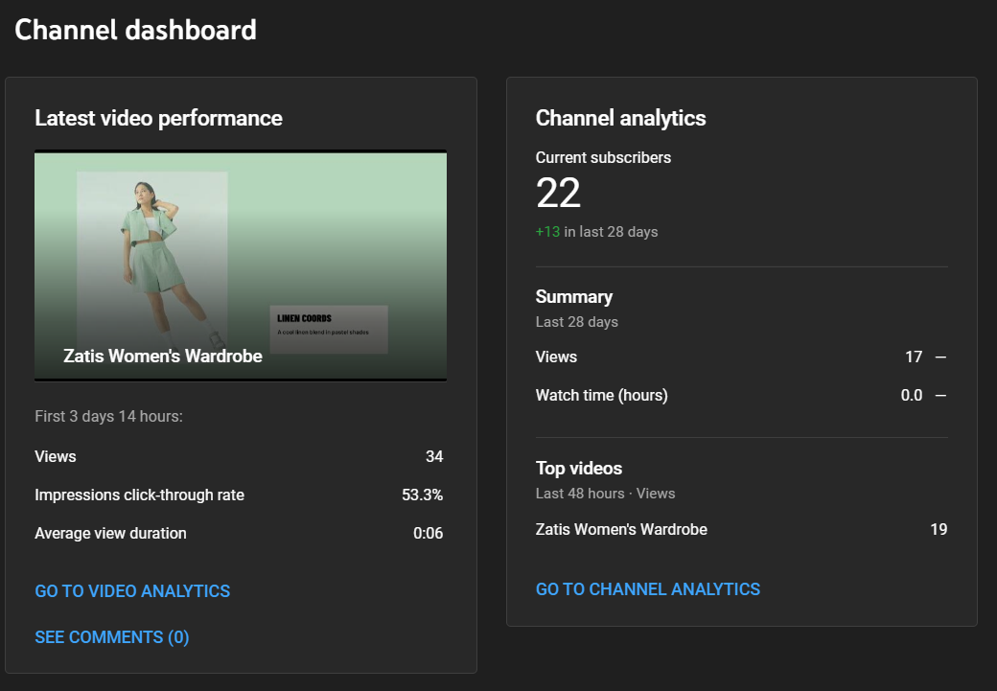

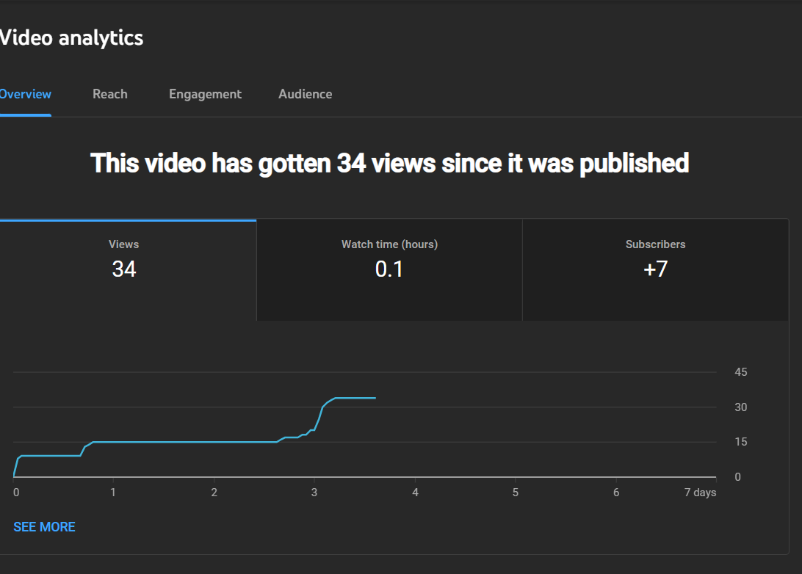

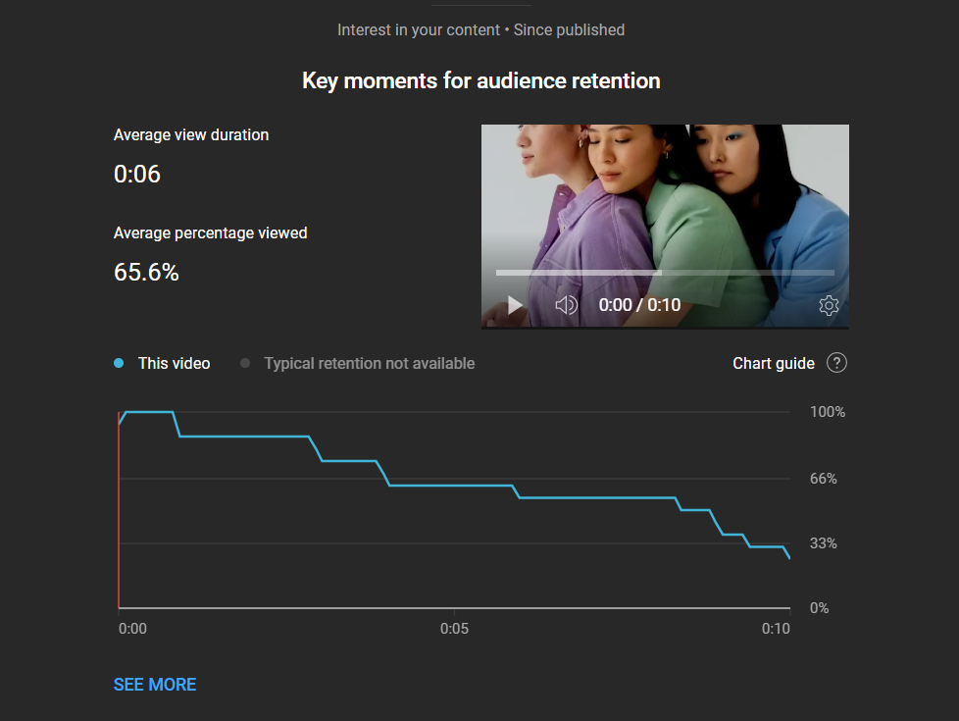

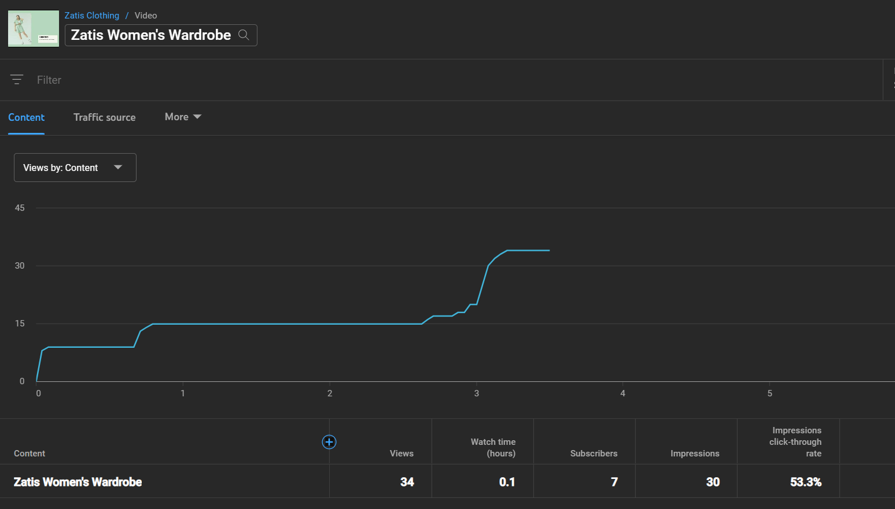

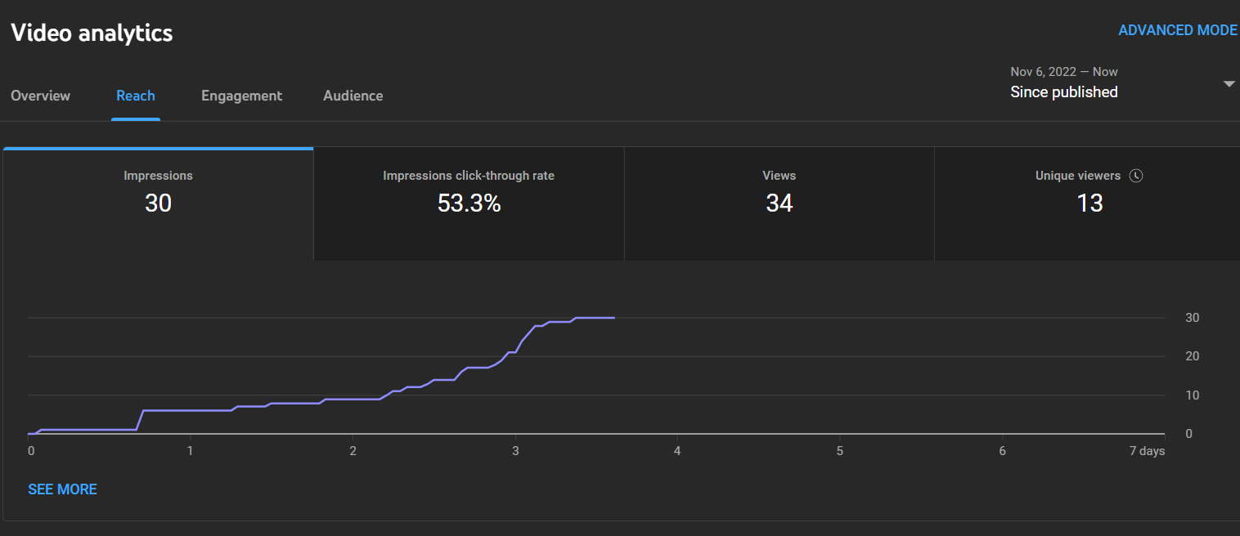

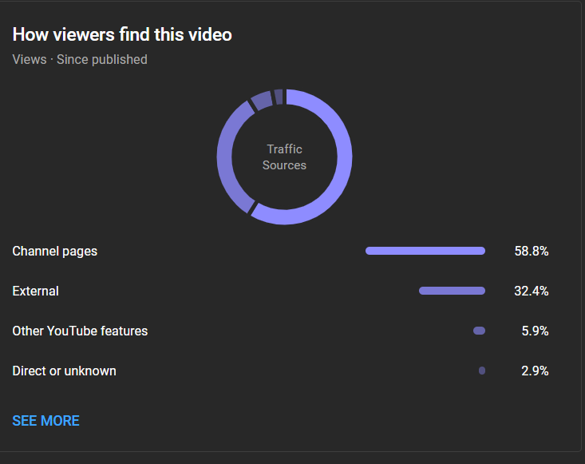

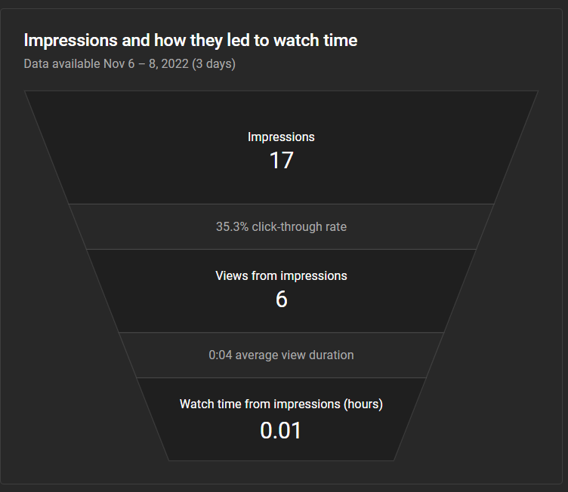

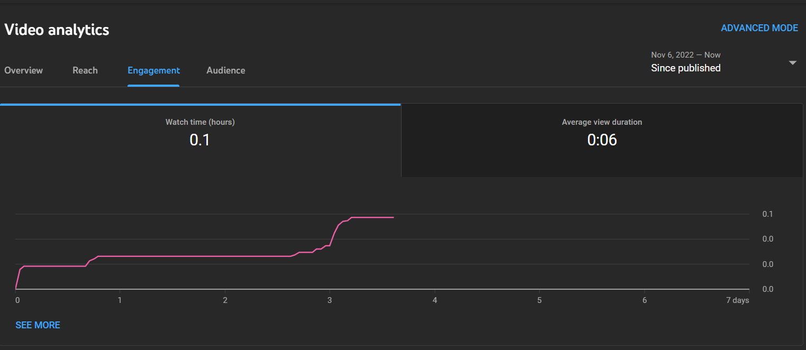

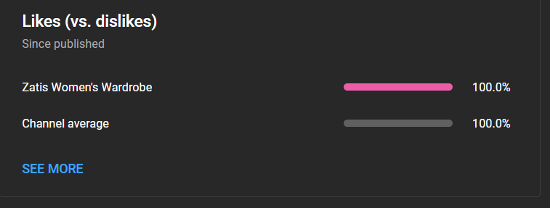



**Twitter Analytics**

**Twitter URL:** https://twitter.com/ZatisClothing

Impressions – Number of times user saw Tweet on twitter

Engagement – Total number of times a user has interacted with a tweet. This includes all clicks anywhere on the tweet.

Engagement Rate – The number of engagements divided by the total number of impressions.

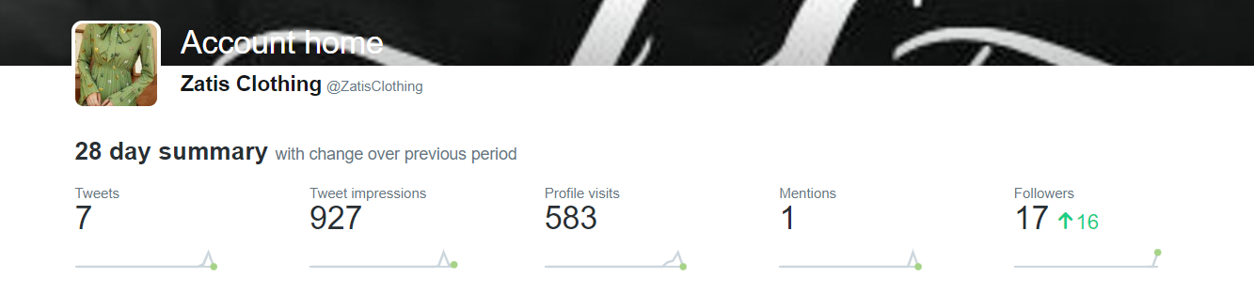

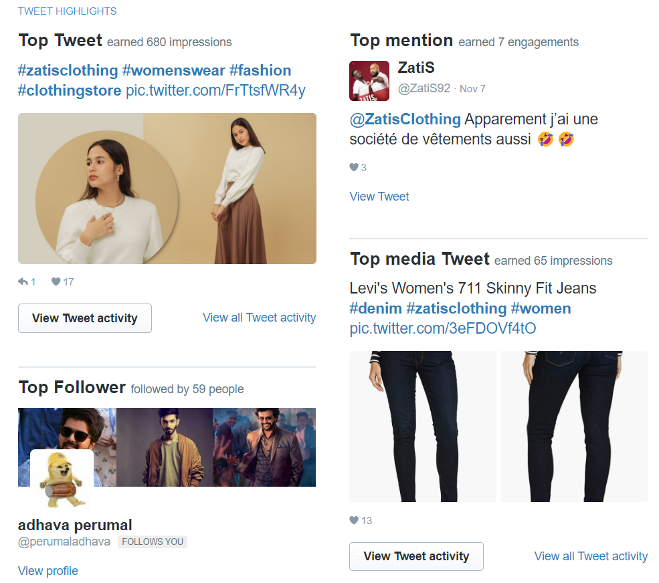

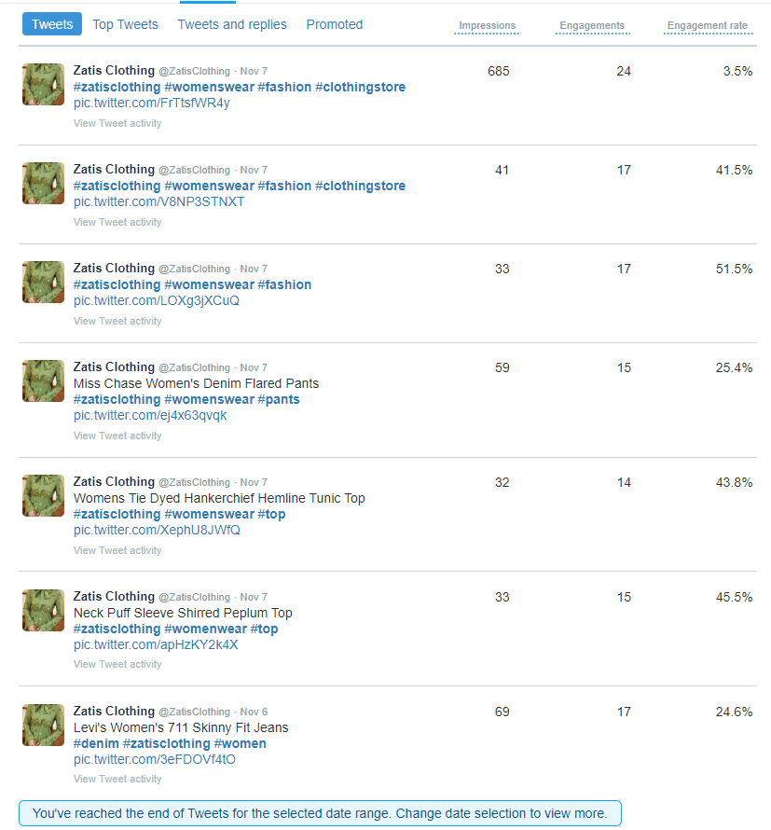



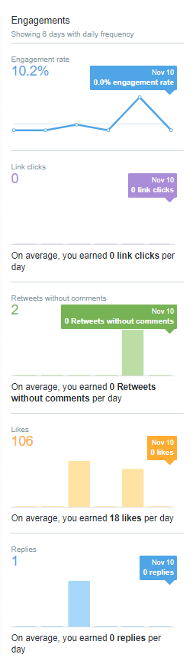



**Instagram Analytics**

**Instagram URL:** https://www.instagram.com/zatisclothing._/

An Instagram analytics report includes key metrics that highlight who your audience is and how your content performs. It includes:

* Profile statistics (follower count, impressions, profile views, and website clicks)
* Audience demographics (top countries, age, gender, and most active times)
* Post summary (median reach, likes, comments, and engagement rate)
* Top performing posts
* Instagram Stories summary (median impressions, reach, and replies)
* Top performing Instagram Stories

